|  |  |
| --- | --- |
| Team ID | PNT2022TMID14185 |
| Project Name | Smart Farmer-IOT Enabled smart Farming application |

IBM Cloud services

Dashboard

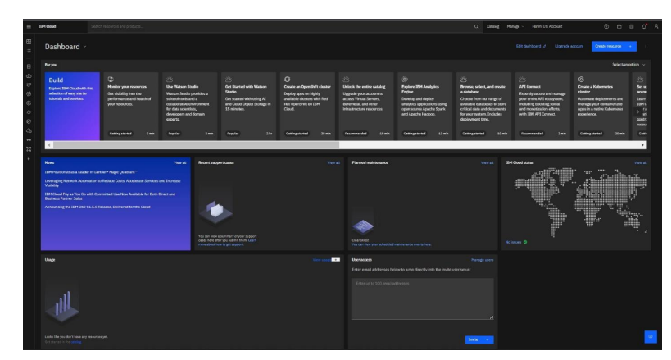

Account Settings

